Chicken Foot

Subject:  Related Subjects: | Grade Level(s):  Length of Lesson: | Type: Inquiry / Design / Project  Keywords:

Lesson Overview
Use this section to describe at a high level what the lesson is. Should be no more than 3-4 lines.

Lesson Focus
What is the central question or phenomenon being investigated? What problem are they trying to solve?

Lesson Objective(s) | By the end of this lesson, students will…  - Learn the concepts of attraction, repulsion, friction, polarity, and charge.

Lesson Timing

5 minutes | Introduce the Lesson
30 minutes | ...

Materials | - 20 Dissection Kit  - 20 Latex gloves  - 20 Xacto knives  - 20 Dissection Tray  - 20 Chicken Foot
Instructor Prep | - Step 1
Related Resources | - List related lessons/ppts etc available from USC or outside, trusted orgs

Lesson Plan

Introduction
Introduce students to the learning goals and make connections to past and present learning experiences. Stimulate interest and prompt students to identify their own questions about the topic. This can link the lesson to real world examples, introduce associated STEM careers, and assess their prior knowledge on the topic.

- Step 1

Procedure
- Place the chicken foot into the tray with the “palm” facing up.
- Find the silvery white tough connective tissue that is near the top of the foot next to the bone.
- Using the X‐Acto knife, slit the top layer of the skin.
- Taking the sharp end of the scissors, cut through the layer right below the chicken’s
skin near the open end all the way down the “palm” of foot.
- Find the bundle of tendons directly in the mid point.
- Using the forceps, pull the tendons out of the slit (you may use your hands, but the tendons may be too slippery because of the glove).
- Pull the tendon mass and observe what happens
- Separate the tendons and pull each individually and observe what happens
- Place the chicken foot “palm” down
- Using the X‐Acto knife, slit the top layer of the skin.
- Taking the sharp end of the scissors, cut through the layer right below the chicken’s
skin near the opening and find the tendon on the back of the foot
- Pull the tendon and observe what happens.
- Look for the muscles on the chicken foot. The muscles are bundles of dark pink tissue that surrounds the bone.
- Look for whitish tissue, or ligaments, between the bones. Look for a thin strand of material with your dissecting needle. Carefully pull the strand aside with the dissecting needle. This strand is a nerve.
- Look for a thin reddish‐brown strand of tissue. Pull it aside with the dissecting needle. This strand is a blood vessel.

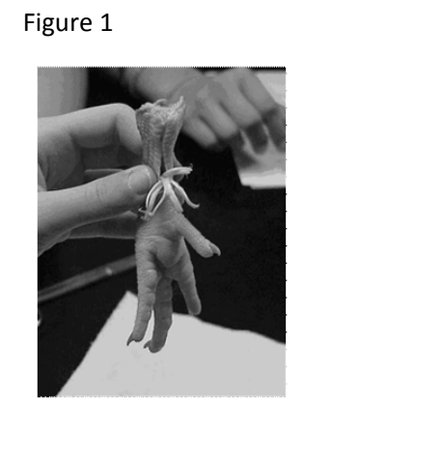

Wrap-up
End the lesson with some final discussions about what students designed/discovered. Connect their activity back to the focus question/problem, real world examples, and STEM careers.

Also include notes about any special cleanup considerations

Lesson Background for Teachers

Suggested Real-World STEM Connections
- List possible related Role Models in STEM (with details and links to more reading). Give suggestions for examples of scientists/engineers who are from underrepresented groups in STEM in related careers.
- List related real-world engineering problems and examples

Lesson Variations and Options
Include descriptions of alternative methods or ways to present things.

Explanation
Describe the background concepts and explanations behind the lesson. This can be more in depth than a teacher/instructor would actually share with students.

Key Concepts and Vocabulary
- Word 1: Grade Appropriate Definition
- Word 2: Grade Appropriate Definition

Safety Notes
- Safety instruction

